|  |
| --- |
| Written by: Ramin Kurkeice, Ahmad El-Hajj, Matthew Phillip |

Solar Panel Monitor By MARS

Computer Engineering Technology

Status

/1 Hardware present?

/1 Title Page

/1 Declaration of Joint Authorship

/1 Proposal (500 words)

/1 Executive Summary

# Declaration of Joint Authorship

We, Ramin Kurkeice, Ahmad El-Hajj, and Matthew Phillip, we acknowledge that this work is submitted by the group work of all members and is expressed in our own words and work that is paraphrased accordingly. Any uses made within the work of any other author/ authors. Any uses made within it of the works of any other author, in any form (ideas, equations, figures, texts, tables, programs), are properly acknowledged at the point of use. A list of the references used is included. The work breakdown is as follows: Each of us provided functioning, documented hardware for a sensor or effector. Ramin Kurkeice provided the ZPT101B. Ahmad El-Hajj provided the current sensor. Matthew Phillip provided temp sensor. In the integration effort Matthew is the lead for further development of our mobile application, Ahmad is the lead for the Hardware, and Ramin is the lead for connecting the two via the Database.

# Proposal

We have created a mobile application, worked with databases, completed a software engineering course, and prototyped a small embedded system with a custom PCB as well as an enclosure (3D printed/laser cut). Our Internet of Things (IoT) capstone project uses a distributed computing model of a smart phone application, a database accessible via the internet, an enterprise wireless (capable of storing certificates) connected embedded system prototype with a custom PCB as well as an enclosure (3D printed/laser cut), and are documented via this technical report targeting OACETT certification guidelines.

Intended project key component descriptions and part numbers  
Development platform:   
Sensor/Effector 1: Lumosity sensor  
Sensor/Effector 2: current sensor  
Sensor/Effector 3: power sensor

We will continue to develop skills to configure operating systems, networks, and embedded systems using these key components to create the solar panel sensor and track info from the device and place it within the database. We plan on making the mobile application work with the intended design of the tracker and pull data from the device when needed. and make the device with the skills learned from the previous semesters such as CENG 251, CENG 254, CENG 322, and CENG 317 to effectively create a downsized prototype of the capstone and to make the necessary decisions and teamwork to create the work.

Our project description/specifications will be reviewed by, Dr. Dragos Paraschiv. They will also ideally attend the ICT Capstone Expo to see the outcome and be eligible to apply for NSERC funded extension projects..

The small physical prototypes that we build are to be small and safe enough to be brought to class every week as well as be worked on at home. In alignment with the space below the tray in the Humber North Campus Electronics Parts kit the overall project maximum dimensions are 12 13/16" x 6" x 2 7/8" = 32.5cm x 15.25cm x 7.25cm.

Keeping safety and Z462 in mind, the highest AC voltage that will be used is 16Vrms from a wall adapter from which +/- 15V or as high as 45 VDC can be obtained. Maximum power consumption will not exceed 20 Watts. We are working with prototypes and that prototypes are not to be left powered unattended despite the connectivity that we develop.

# Executive Summary

Business Need/Opportunity

Humber College Institute of Technology and Advanced Learning, Has installed 4 solar panels to the gazebo in the campus although unsure of how much power is being collected the MARSINC team as decided to work with Humber to created a prototype that would connect a database with the device and display reading on to the application.

This would bring interest in the Humber community two have visual proof of power collection and further inspire clean energy from the client and hopefully inspire more companies and businesses to implement similar technology.

What we hope to achieve is a framework to be built upon in the field of clean energy recording and data sharing.

Statement of Work

This effort includes the following:

Created Printed Circuit Boards (PCB) to house the wired components in as small as possible.

* Create and improve an encasing for the device that protects and improves portability.
* Make a mobile application that is simple, easy to use, and free to access.
* Create a database and store readings from the device to be retrieved from the application.

Contents

Declaration of Joint Authorship 3

Proposal 5

Executive Summary 7

List of Figures 11

1.0 Introduction 13

1.1 Scope and Requirements 13

2.0 Background 15

3.0 Methodology 17

3.1 Required Resources 17

3.1.1 Parts, Components, Materials 17

3.1.2 Manufacturing 17

3.1.3 Tools and Facilities 17

3.1.4 Shipping, duty, taxes 17

3.1.5 Time expenditure 17

3.2 Development Platform 17

3.2.1 Mobile Application 17

3.2.2 Image/firmware 19

3.2.3 Breadboard/Independent PCBs 19

3.2.4 Printed Circuit Board 21

3.2.5 Enclosure 22

3.3 Integration 23

3.3.1 Enterprise Wireless Connectivity 24

3.3.2 Database Configuration 24

3.3.3 Security 24

3.3.4 Testing 24

4.0 Results and Discussions 25

5.0 Conclusions 27

6.0 References 29

7.0 Appendix 31

7.1 Firmware code 31

7.2 Application code 31

# List of Figures

Figure 1. By Android Studio - https://developer.android.com/studio/, CC BY-SA 4.0, https://commons.wikimedia.org/w/index.php?curid=74094999 19

Figure 2. Initial schematic. This work is a derivative of "http://fritzing.org/parts/" by Fritzing, used under CC:BY-SA 3.0. 20

Figure 3. This work is a derivative of "http://fritzing.org/parts/" by Fritzing, used under CC:BY-SA 3.0. 20

Figure 4. Breadboard prototype. 21

Figure 5. PCB design This work is a derivative of "http://fritzing.org/parts/" by Fritzing, used under CC:BY-SA 3.0. 22

Figure 6. Humber Sense Hat Prototype PCB. 22

Figure 7. Example enclosure. 23

# Introduction

Mars is a small organization of students that are taking on this capstone project for Humber college institute of advanced learning and technology on the Solar panel monitoring of the solar panels on the gazebo. We are omitting the website application as we believe that the mobile application is more compact easy to access and can be ported to a website in the future. We are including a Lumosity sensor as well as a current and voltage sensor to calculate power and lux of the solar panel. We also are making a database that collects this information and adds it to the mobile application. We undertook this assignment as a way to help improve our skills and inspire companies to maintain solar panels. The problems we have are Humber is unable to access the database of the solar panels from the original installers and we must make one from scratch we believe this will set back our project but we are confidant in finishing the product.

## 1.1 Scope and Requirements

The solar monitoring system is an Internet of Things (IoT) capstone project that uses a

distributed computing model of a smart phone application, a web application, a

database accessible via the inter, an enterprise wireless (capable of storing certificates)

connected embedded system prototype with a custom PCB as well as a laser cut

enclosure, and is documented via an OACETT certification acceptable technical report.

The capstone project must be able to fit in the space below the tray in the Humber North

Campus Electronics Parts kit the overall project maximum dimensions are 12 13/16" x

6" x 2 7/8" = 32.5cm x 15.25cm x 7.25cm. Keeping safety and Z462 in mind, the highest

AC voltage that will be used is 16Vrms from a wall adapter from which +/- 15V or as

high as 45 VDC can be obtained. Maximum power consumption will not exceed 20

Watts. Android device must have a data visualization activity and action control activity.

CSA testing will not be done in this project. Database must collect data at a frequent

time and must be accessible through web and mobile application

The solar monitoring system is an Internet of Things (IoT) capstone project that uses a

distributed computing model of a smart phone application, a web application, a

database accessible via the inter, an enterprise wireless (capable of storing certificates)

connected embedded system prototype with a custom PCB as well as a laser cut

enclosure, and is documented via an OACETT certification acceptable technical report.

The capstone project must be able to fit in the space below the tray in the Humber North

Campus Electronics Parts kit the overall project maximum dimensions are 12 13/16" x

6" x 2 7/8" = 32.5cm x 15.25cm x 7.25cm. Keeping safety and Z462 in mind, the highest

AC voltage that will be used is 16Vrms from a wall adapter from which +/- 15V or as

high as 45 VDC can be obtained. Maximum power consumption will not exceed 20

Watts. Android device must have a data visualization activity and action control activity.

CSA testing will not be done in this project. Database must collect data at a frequent

time and must be accessible through web and mobile application

The solar monitoring system is an Internet of Things (IoT) capstone project that uses a distributed computing model of a smart phone application, a web application, a database accessible via the internet, an enterprise wireless (capable of storing certificates) connected embedded system prototype with a custom PCB as well as a laser cut enclosure and 3d print, and is documented via an OACETT certification acceptable technical report. The capstone project must be able to fit in the space below the tray in the Humber NorthCampus Electronics Parts kit the overall project maximum dimensions are 12 13/16" x 6" x 2 7/8" = 32.5cm x 15.25cm x 7.25cm. Keeping safety and Z462 in mind, the highestAC voltage that will be used is 16Vrms from a wall adapter from which +/- 15V or as high as 45 VDC can be obtained. Maximum power consumption will not exceed 20 Watts. Android device must have a data visualization activity and action control activity. CSA testing will not be done in this project. Database must collect data at a frequent time (every 30 minutes) and must be accessible through mobile application.

Report

/1 Hardware present?

/1 Introduction (500 words)

/1 Scope and Requirements

/1 Background (500 words)

/1 References

# 2.0 Background

We would like to thank our sponsor, Dr. Dragos Paraschiv from Humber institute of advance learning and technology for supporting this project. Solar panels monitoring has been a part of the process for solar panel instillation for years. We believe that the system in place for solar panel monitoring is help with companies who are carbon footprint conscience to manage the steady supply of power and Lumosity to properly understand and quality check the solar panels that were installed. According to the Ontario solar installers they state that when a solar panel is installed it isn’t ideal to have it running and move on with your day as it is important to have monitoring of the solar panel because it can help with checking of quality of energy from time to time as well is making sure everything is working correctly. (Ontario Solar Installers, 2019). Thus we use monitoring when solar panels are installed to check the proper Lumosity input on a certain day for example a sunny day should yield more power although we check the monitoring software and find that the Lumosity is lower than expected we can then cross examine the sensors and fix the problem before a more expensive solution is reached. We are doing this capstone in response to Humber college institute of advanced learning and technology due to their mission statement that they would like to reduce carbon emission by a considerable amount every year. Humber college installed solar panels to the gazebo in the college grounds over the summer of 2019. Their goal was shaped by their recognition of clean energy and have won awards for their determination according to MediaCorp Canada Inc. They state that Humber college is one of four colleges that won the 2019 greenest employers award as they showcase a number of green features like water bottle stations, bio walls, PV solar panels, etc. (Yerema & Kristina , 2019). with this information Humber wanting to further green energy we are tasked to monitor these new solar panels. As stated above the importance of monitoring these solar panels is to make sure that clean energy is maintained for as long as possible. This can inspire more businesses to follow green energy as it holds a lot of benefits. RecSolar states that many expanding businesses invest in solar power as they take advantage of a new facility and infostructure this investment can also provide branding and community goodwill with the public for reducing carbon footprints and help with increase your total savings in energy storage. (RecSolar, 2017). These and more are the reason why we plan to take this capstone project and as we see the world is more conscious of green energy and reducing carbon footprints it is also very important that companies are responsible to monitor it as well to ensure quality in power management. These can benefit business in the future on power consumption, energy storage, and reduce cost. Thus our capstone’s goal is to help inspire organizations to maintain quality of solar panels.

# 3.0 Methodology

## 3.1 Required Resources

Report

/1 Parts/components/materials (500 words)

/1 PCB, case (500 words)

/1 Tools, facilities (500 words)

/1 Shipping, duty, taxes (250 words)

/1 Working time versus lead time (250 words)

### 3.1.1 Parts, Components, Materials

### 3.1.2 Manufacturing

### 3.1.3 Tools and Facilities

### 3.1.4 Shipping, duty, taxes

### 3.1.5 Time expenditure

Working time versus lead time.

## 3.2 Development Platform

### 3.2.1 Mobile Application

Status

/1 Hardware present?

/1 Memo by student A + How did you make your Mobile Application? (500 words)

/1 Login activity

/1 Data visualization activity

/1 Action control activity

Include screenshots such as Figure 1. Testing. Progress.

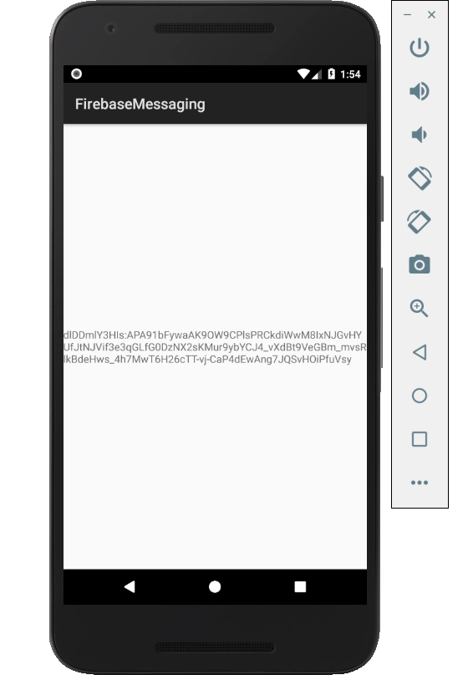

Figure 1. By Android Studio - https://developer.android.com/studio/, CC BY-SA 4.0, https://commons.wikimedia.org/w/index.php?curid=74094999

### 3.2.2 Image/firmware

Status

/1 Hardware present?

/1 Memo by student B + How did you make your Image/firmware? (500 words)

/1 Code can be run via serial or remote desktop

/1 Wireless connectivity

/1 Sensor/effector code on repository

### 3.2.3 Breadboard/Independent PCBs

Status

/1 Hardware present?

/1 Memo by student C + How did you make your hardware? (500 words)

/1 Sensor/effector 1 functional

/1 Sensor/effector 2 functional

/1 Sensor/effector 3 functional

The initial schematic design, Figure 2, based on datasheets (Bosch Sensortec, 2019) led to a breadboard layout Figure 3 that was realized Figure 4.

How did you build your Prototype: Breadboard?

Then a PCB was designed, Figure 5, and populated (Figure 6). Bill of Materials, Case, Time commitment. Testing. Progress.

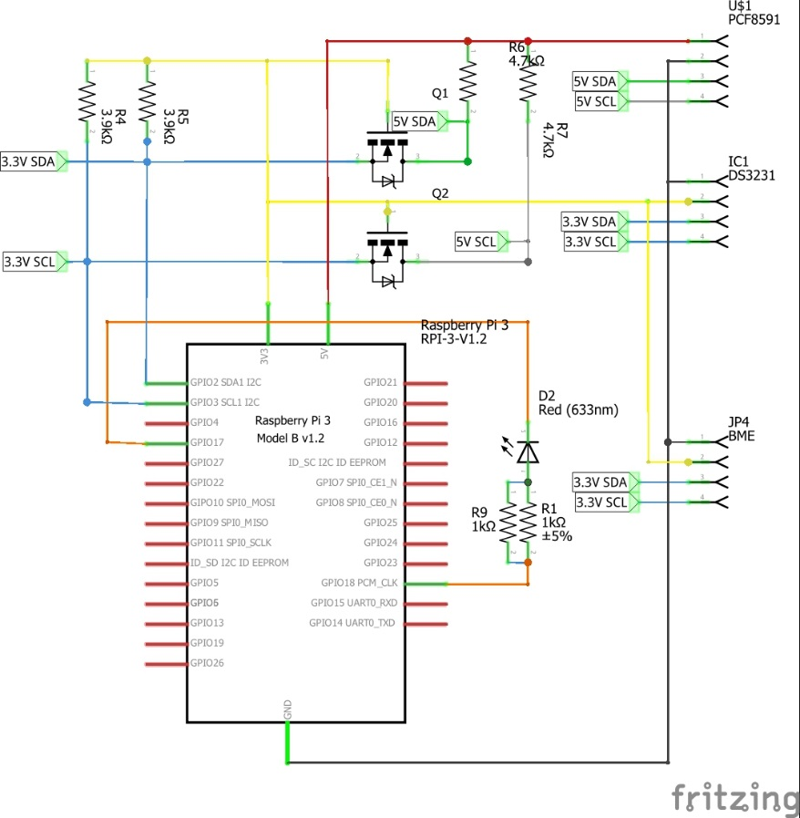

Figure 2. Initial schematic. This work is a derivative of "http://fritzing.org/parts/" by Fritzing, used under CC:BY-SA 3.0.

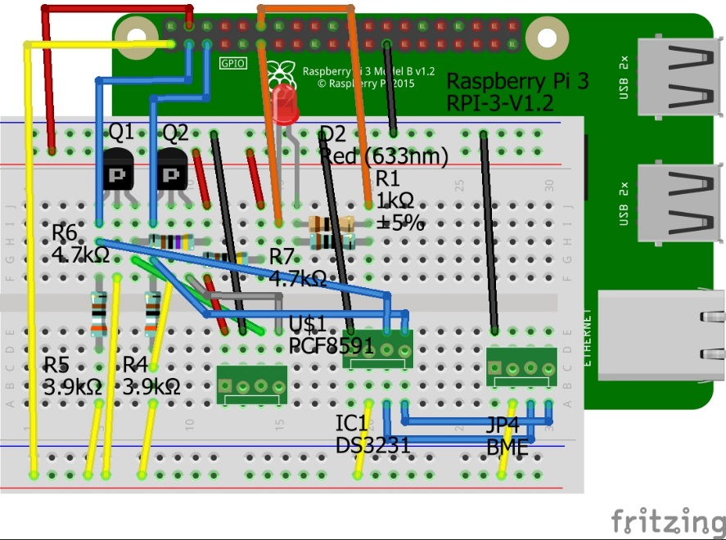

Figure 3. This work is a derivative of "http://fritzing.org/parts/" by Fritzing, used under CC:BY-SA 3.0.

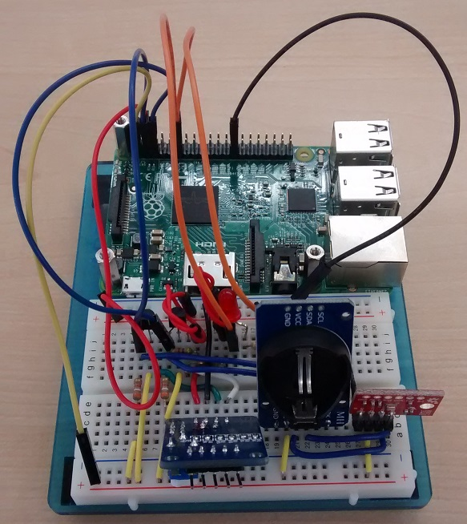

Figure 4. Breadboard prototype.

### 3.2.4 Printed Circuit Board

Demo

/1 Hardware present?

/1 PCB Complete and correct

/1 PCB Soldered wire visible but trim, no holes or vacancies

/1 PCB Tested with multimeter

/1 PCB Powered up

How did you build your Prototype: PCB?

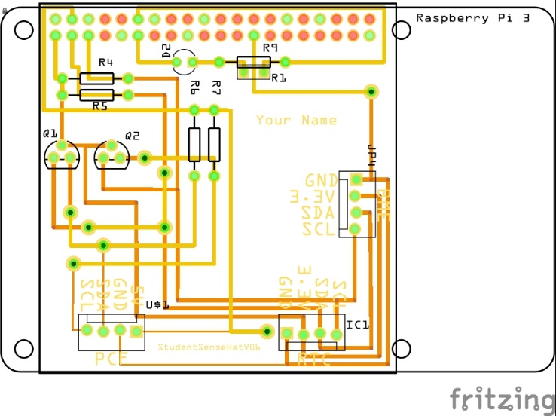

Figure 5. PCB design This work is a derivative of "http://fritzing.org/parts/" by Fritzing, used under CC:BY-SA 3.0.

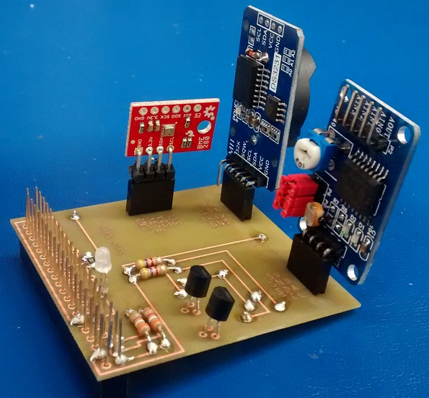

Figure 6. Humber Sense Hat Prototype PCB.

### 3.2.5 Enclosure

Demo

/1 Hardware present?

/1 Case encloses development platform and custom PCB.

/1 Appropriate parts securely attached.

/1 Appropriate parts accessible.

/1 Design file in repository, photo in report.

How did you build your Prototype: Case?

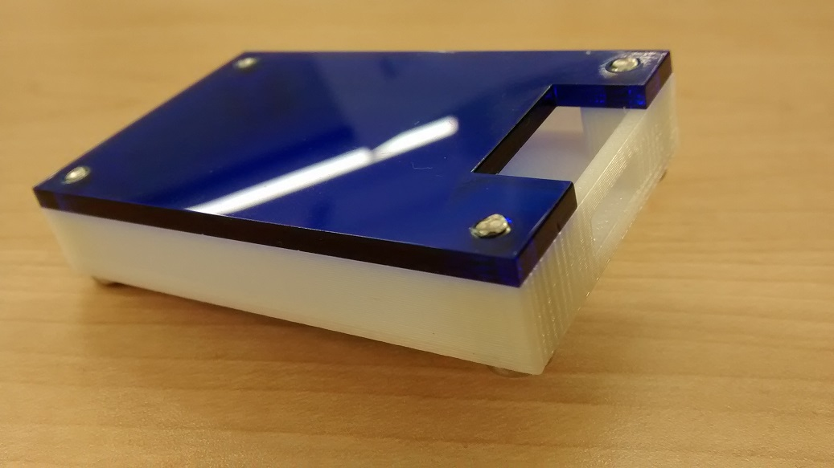

Figure . Example enclosure.

## 3.3 Integration

Demo

/1 Hardware present?

/1 Data sent by hardware

/1 Data retrieved by mobile application

/1 Action initiated by mobile application

/1 Action recieved by hardware

Report

/1 Enterprise wireless connectivity (250)

/1 Database configuration (250 words)

/1 Security considerations (500 words)

/1 Unit testing (900 words)

/1 Production testing (100 words)

### 3.3.1 Enterprise Wireless Connectivity

How did you make a Database accessible by both your Prototype and Mobile Application?

### 3.3.2 Database Configuration

### 3.3.3 Security

### 3.3.4 Testing

Unit testing and Production testing.

# 4.0 Results and Discussions

Is your prototype perfect? What did you learn?

# 5.0 Conclusions

If you were making 1000 of these.

Report

/1 Hardware present?

/1 Checklist truthful

/1 Valid Comments

/1 Results and Discussion (500 words)

/1 Conclusion

# 6.0 References

Bosch Sensortec. (2019, July). *BME680 - Datasheet.* Retrieved from Robert Bosch GmbH: https://ae-bst.resource.bosch.com/media/_tech/media/datasheets/BST-BME680-DS001.pdf

Ontario Solar Installers. (2019, march 25). *Why do you need a Solar Monitoring*. Retrieved from Ontario solar installers.ca: https://ontario-solar-installers.ca/solar-panel-installers/why-do-you-need-a-solar-monitoring-system/

RecSolar. (2017). *solar for business*. Retrieved from Recsolar.com.

Yerema, R., & Kristina , L. (2019, april 14). Humber college recoginzed as one of canada's greenest employers. *canadastop100*, 1.

# 7.0 Appendix

## 7.1 Firmware code

Demo

/1 Hardware present?

/3 Code runs concurrently for all sensors/effectors

/1 Project repository contains integrated code

Status

/1 Memo including updates

/1 Financial update

/1 Progress update

/1 Modified Code Files in Appendix

/1 Link to Complete Code in Repository

## 7.2 Application code

Demo

/1 Hardware present?

/1 Memo by student A

/1 Login activity

/1 Data visualization activity

/1 Action control activity

Report

/1 Login activity

/1 Data visualization activity

/1 Action control activity

/1 Modified Code Files in Appendix

/1 Link to Complete Code in Repository